
BAR CODE MEDICATION ADMINISTRATION (BCMA)
NURSING CHUI USER MANUAL
Version 3.0
February 2004
(Revised October 2004)

Department of Veterans Affairs
VISTA Health Systems Design & Development

Revision History

Each time this manual is updated, the Title Page lists the new revised date and this page describes the changes. Either update your existing manual with the Change Pages document, or replace it with the updated manual.

Note: The Change Pages document may include unedited pages needed for two-sided copying. Only edited pages display the patch number and revision date in the page footer.

Date | Revised Pages | Patch Number | Description
10/2004 | iii-iv,  5  14-18,  50  53-54 | PSB*3*3 | – Added a note in the Table of Contents and Table of Exhibits about section 3.5 and Exhibits 7-10 being moved to the GUI BCMA pkg./manual. (p. iii-iv)  – Removed the reference to the Edit Medication Log in the second paragraph, and updated Exhibit 1: BCMA Nursing Option Menu Screen. (p. 5)  – Removed section 3.5 and Exhibits: 7-10 and replaced with blank pages, since the Edit Medication Log functionality was removed from the CHUI BCMA and incorporated into the GUI BCMA package and the associated user manual. (p. 14-18)  -- Updated definition of “Not Given” and fixed typos on page. (p. 50)  – In the Index, under the “Sample Screens” and “Using the Medication Administration Menu Nursing Options” sections removed references to pages 14-18 since the Edit Medication Log functionality was removed from the CHUI BCMA and this user manual. (p. 53-54).
07/2004 | 36, 37 | PSB*3*5 | – Updated the second paragraph to include the “Allergies” information.  (p. 36)  – Updated the “Example 25: Medication Administration History Report by Patient” to show the removal of the Reactions header and the inclusion of the ADRs header and the Allergies header. (p. 37)
02/2004 |  |  | Original Released BCMA V. 3.0 Nursing CHUI User Manual.

TABLE OF CONTENTS

1 introduction 1
1.1 What is BCMA? 1
1.2 Features of BCMA 1
2 About This Manual 3
2.1 Special Notations—Documentation Conventions 3
2.2 Package Conventions 3
2.3 Intranet Documentation 3
2.4 On-line Help 3
3 BCMA Menu—Nursing Option 5
3.1 Using the Medication Administration Menu Nursing Option 5
3.2 Using ScreenMan Format to Request a Report 6
3.3 Medication Administration Log Report 8
3.4 Missed Medications Report 11
3.5 Edit Medication Log (Note: Functionality moved to GUI BCMA pkg./manual.) 14
3.6 Ward Administration Times Report 19
3.7 Due List Report 22
3.8 PRN Effectiveness List Report 26
3.9 Enter PRN Effectiveness 28
3.10 Manual Medication Entry 31
3.11 Medication Administration History (MAH) Report 36
3.12 Missing Dose Request 38
3.13 Medication Variance Log Report 42
3.14 Drug File Inquiry 44
glossary 47
Acronyms 47
Terms 48
INDEX 53

TABLE OF EXHIBITS

Exhibit 1: BCMA Nursing Option Menu Screen 5
Exhibit 2: Report Request Using ScreenMan Format Screen 6
Exhibit 3: Medication Administration Log Report by Patient 9
Exhibit 4: Medication Administration Log Report by Ward 10
Exhibit 5: Missed Medications Report by Patient 12
Exhibit 6: Missed Medications Report by Ward 13
Exhibits 7-10: Edit Medication Log and related screens were deleted from this pkg./manual.
(Note: Functionality moved to GUI BCMA pkg./manual.)
Exhibit 11: Administration Times Report by Patient 20
Exhibit 12: Administration Times Report by Ward 21
Exhibit 13: Due List Report Request Screen 22
Exhibit 14: Due List Report by Patient 24
Exhibit 15: Due List Report by Ward 25
Exhibit 16: PRN Effectiveness List Report by Patient 26
Exhibit 17: PRN Effectiveness List Report by Ward 27
Exhibit 18: Patient Selection Screen 28
Exhibit 19: Medication Selection Screen 29
Exhibit 20: PRN Effectiveness Entry Screen 30
Exhibit 21: Manual Medication Entry Patient Selection Screen 31
Exhibit 22: Manual Medication Entry Medication Selection Screen 32
Exhibit 23: Administration Time Selection Screen 33
Exhibit 24: Medication Log Manual Entry Screen 34
Exhibit 25: Medication Administration History Report by Patient 37
Exhibit 26: Missing Dose Request Screen 38
Exhibit 27: Missing Dose Request Confirmation Screen 40
Exhibit 28: Missing Dose E-mail Notification 41
Exhibit 29: Medication Variance Log Report by Patient 42
Exhibit 30: Medication Variance Log Report by Ward 43
Exhibit 31: Drug File Inquiry Screen 1 44
Exhibit 32: Drug File Inquiry Screen 2 45

introduction

What is BCMA?
The Bar Code Medication Administration (BCMA) V. 3.0 software includes routines and files, Phase Release changes for BCMA V. 2.0, maintenance fixes, and enhancements. The enhancements are a direct result of feedback from the BCMA Workgroup and our many end users.

BCMA software is designed to improve the accuracy of the medication administration process. By automating this process, Department of Veterans Affairs Medical Centers (VAMCS) can expect enhanced patient safety and patient care.

As each patient wristband and medication is scanned with a bar code scanner, BCMA validates that the medication is ordered, timely, and in the correct dosage — as well as electronically updates the patient’s Medication Administration History (MAH) Report.

The electronic information provided by BCMA V. 3.0 improves the clinician’s ability to administer medications safely and effectively to patients on wards during their medication passes. It also helps to improve the daily communication that occurs between Nursing and Pharmacy staffs.

Features of BCMA
BCMA V. 3.0 provides the following features:

- Increases medication administration accuracy.
- Improves the efficiency of the medication administration process by capturing drug accountability data.
- Records Unit Dose, IV Push (IVP), IV Piggyback (IVPB), and large-volume IVs administered to patients.
- Provides the CPRS Med Order Button, a “link” to the Computerized Patient Record System (CPRS) for electronically ordering, documenting, reviewing, and signing verbal- and phone-type STAT and NOW (One-Time) orders for Unit Dose and IV medications already administered to patients.
- Increases the information available to nursing staff at the patient point of care.
- Reduces wasted medications.
- Improves communication between Nursing and Pharmacy staffs.
- Provides a real-time Virtual Due List (VDL) of orders for medication administration.
- Records missing doses and sends the requests electronically to the Pharmacy.
- Provides a point-of-care data entry/retrieval system.
- Provides full compatibility with the existing VISTA system.
- Identifies Pro Re Nata (PRN) entries that require Effectiveness comments.
- Replaces the manual Medication Administration Record (MAR) with a Medication Administration History (MAH) to provide an automatic record of a patient’s medication administration information.
- Provides a list of variances that identify Early or Late medication administrations and late PRN Effectiveness entries.
- Provides the ability to document the patient’s pain score in BCMA and store it in the Vitals package.

About This Manual
This manual contains a description of the Character-based User Interface (CHUI) BCMA options for the Pharmacy user. It is organized around the Medication Administration Menu Pharmacy Options. It explains how to access and use each option, and provides sample screen captures and reports. An Index and a Glossary are available at the back of this manual.

Special Notations—Documentation Conventions
Responses in boldface type indicate what you should type at your computer screen. Example: At the “Patient/Ward:” prompt, type P for Patient or W for Ward.

Text centered between arrows represents a keyboard key that needs to be pressed for the system to capture a user response or move the cursor to another prompt. <Enter> indicates that the Enter key (or Return key on some keyboards) must be pressed. <Tab> indicates that the Tab key must be pressed. Example: Press <Tab> to move the cursor to the next prompt. Enter Y for Yes or N for No, and then press <Enter>.

- Indicates especially important or helpful information.

Package Conventions
Up-arrow (caret or a circumflex)
In CHUI BCMA, you can move back to a previous screen by entering a ^ and then pressing <Enter>. Repeat this process until you locate the desired screen.

2.3 Intranet Documentation
You can locate this and other BCMA-related documentation on the Intranet, from the VISTA Documentation Library (VDL), at the following address. It provides background, technical information, and important user documentation.

http://www.va.gov/vdl

 Remember to bookmark this site for future reference.

On-line Help
?, ??, ???
On-line help is available by entering one, two, or three question marks at a prompt. One question mark elicits a brief statement of what information is appropriate for the prompt; two question marks elicits more help, plus the hidden actions shown above; and three question marks will provide more detailed help, including a list of possible answers, if appropriate.

BCMA Menu—Nursing Option

Using the Medication Administration Menu Nursing Option
The BCMA Nursing Option Menu, as illustrated in Exhibit 1, lets Nursing personnel access information that has been entered via the BCMA Graphical User Interface (GUI) VDL. Because BCMA operates in real time, scanned information is available as soon as the scan is successfully completed. You can access the Nursing Option Menu from any VISTA-enabled terminal within the VAMC.

 Several of these options are available under both the Nursing and the Pharmacy menu options. The options that are unique to Nursing include Ward Administration Times, PRN Effectiveness List, Enter PRN Effectiveness, Manual Medication Entry, and Medication Variance Log.

Exhibit 1: BCMA Nursing Option Menu Screen
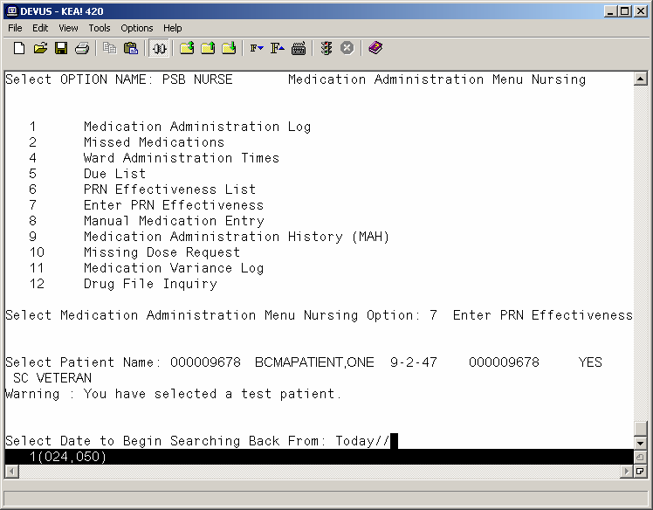

To select a Nursing option:
- At the “Select Medication Administration Menu Nursing Option:” prompt, enter the number of the desired option.
- Press <Enter> to display the Sort Screen for the option chosen.

Using ScreenMan Format to Request a Report
Many of the Nursing options use a common screen to define selection criteria for reports, as illustrated in Exhibit 2, Report Request Using ScreenMan Format. Other options use specific screens. This section explains the screen prompts for all reports using the Report Information Sort Screen and gives instructions for entering information. Following this section are sample reports that you can run from each of the Medication Administration Menu Nursing options.

Exhibit 2: Report Request Using ScreenMan Format Screen
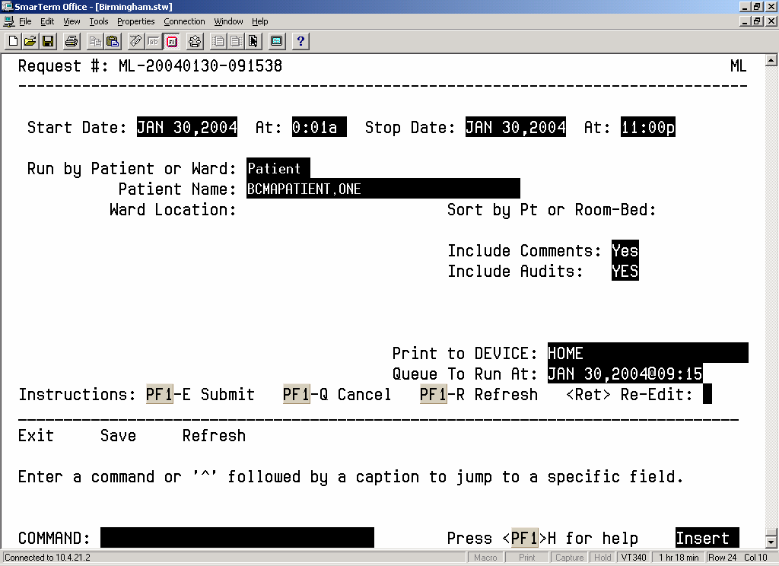

Many of the reports can be sorted and printed in the following ways:
- By patient. The information will display chronologically.
- By ward. The system can sort the information by patient or room/bed, and display it chronologically within each patient.

To request a report using ScreenMan:
- At the “Start Date:” prompt, type the start date of the report, and then press <Enter>.
Note: The cursor moves to the next prompt each time that you press <Enter>.

 To display a list or a standard date and time format, enter a ? at any date or time prompt, and then press <Enter>.

- At the first “At:” prompt, type the start time of the report (in HHMM format), and then press <Enter>.
- At the “Stop Date:” prompt, type the stop date, and then press <Enter>.
- At the second “At:” prompt, type the stop time (in HHMM format), and then press <Enter>.
- At the “Run by Patient or Ward:” prompt, type P for Patient or W for Ward, and then press <Enter>.
- If you are sorting the report by ward, at the “Ward Location:” prompt, type the ward designation, and then press <Enter>. At the “Sort by Pt or Room-Bed:” prompt, type P for Patient or R for Room, and then press <Enter>.
- If sorting the report by patient, at the “Patient Name:” prompt, type the patient’s name or Social Security Number (SSN), and then press <Enter>.

 To display a list, enter a ? at any “Patient Name:” prompt, and then press <Enter>.

- At the “Include Comments:” prompt, enter Y for Yes or N for No, and then press <Enter>.

 If a “Yes/No” prompt is blank, press <Enter> to respond No.

- At the “Include Audits:” prompt, enter Y for Yes or N for No, and then press <Enter>.
- At the “Print to Device:” prompt, type a valid printer, and then press <Enter>.
- At the “Queue to Run At:” prompt, press <Enter> to accept the date displayed, or enter a date and time, and then press <Enter>. The report will print at the time and date entered.
- At the “<RET> Re-Edit:” prompt, press PF1 (or Num Lock), followed by E, to submit this report for printing. (Other available actions at this prompt are PF1-Q to Quit or PF1-R to refresh the screen.)

The screen clears and the following message displays:

Submitting Your Report Request to Taskman…Submitted!
Your Task Number Is: XXXX

- Depending on how your division is configured, either the PF1 key or Num Lock will be active. For consistency, this manual refers to the PF1 convention, but users are advised that PF1 is the same as Num Lock, if that is the active function at your VAMC.

Medication Administration Log Report
The Medication Administration Log [PSBO ML] option lets Nursing personnel create the Medication Administration Log Report, which provides detailed administration information for a specified date/time range. The report can be sorted and printed by patient or by ward. When printed by ward, you may sort the view by patient or room/bed. With this sort, the drug administration information will be printed chronologically within each patient.

The Medication Administration Log Report prints in a 132-column output. Exhibit 3, Medication Administration Log Report by Patient, and Exhibit 4, Medication Administration Log Report by Ward, show examples of both Medication Administration Log Reports.

- Throughout this manual, the reports shown are provided for illustrative purposes only. Actual reports may be longer.

To print a Medication Administration Log Report:
1. At the Medication Administration Menu Nursing Option:” prompt, type 1, and then press <Enter> to access the Medication Administration Log [PSBO ML] option.
2. See Section 3.2, “Using ScreenMan Format to Request a Report,” for instructions about requesting a Medication Administration Log Report.

Exhibit 3: Medication Administration Log Report by Patient
====================================================================================================================================
MEDICATION LOG for Apr 14, 2002@00:01 thru Apr 14, 2002@13:00 Run Date: MAY 05, 2002@09:29
LOG TYPE: INDIVIDUAL PATIENT Page: 1

Patient: BCMAPATIENT,TWO SSN: 000-00-1000 DOB: JAN 2,1941 (58)
Sex: MALE Ht/Wt: */* Ward: BCMA Rm A427-02
Dx: PNEUMONIA Last Mvmt: APR 8, 2002@14:07:51 Type: SPECIALTY TRANSFER

Reactions: STRAWBERRIES
====================================================================================================================================
Orderable Item Admin Admin
Activity Date [Dose/Sched/Route/Inj Site] By Date/Time Drug/Solution/Additive U/Ord U/Gvn Unit
------------------------------------------------------------------------------------------------------------------------------------
12/07/01 08:53 FUROSEMIDE [20MG ON CALL PO] EM 12/07/01 08:53 FUROSEMIDE 20 MG 1.00 1.00 TAB
12/6/01 15:52>
Comments: <No Comments>
1/5/02 24:01<
Audits: <No Audits>
------------------------------------------------------------------------------------------------------------------------------------
12/07/01 08:54 FUROSEMIDE [20MG ON CALL PO] EM 12/07/01 08:54 FUROSEMIDE 20 MG 1.00 1.00 TAB
12/6/01 15:52>

Comments: <No Comments>
1/5/02 24:00<
Audits: <No Audits>
------------------------------------------------------------------------------------------------------------------------------------
12/07/01 09:49 ALBUTEROL [3ML Q4H INHL] EM 12/07/01 11:33 ALBUTEROL 0.083% INHL
SOLUTION 3ML EA. 1.00 1.00 3ml
12/5/01 12:49:40>
Comments: 12/07/01 09:51 EM change in dr's order
12/07/01 10:16 EM Held: PATIENT ON PASS
12/07/01 11:33 EM per pt request
1/4/02 24:00<
Audits: 12/07/01 09:51 EM Field: ADMINISTRATION STATUS 'GIVEN' deleted.
12/07/01 09:51 EM Field: ADMINISTRATION STATUS Set to 'NOT GIVEN'.
12/07/01 09:51 EM Field: DOSES GIVEN '1' deleted.
12/07/01 09:51 EM Field: DOSES GIVEN Set to '0'.
12/07/01 09:51 EM Field: UNIT OF ADMINISTRATION '3 ml' deleted.
12/07/01 09:51 EM Field: UNIT OF ADMINISTRATION Set to '0'.
12/07/01 10:16 EM Field: ADMINISTRATION DATE/TIME 'DEC 07, 2001@09:49:48' deleted.
12/07/01 10:16 EM Field: ADMINISTRATION DATE/TIME Set to 'DEC 07, 2001@10:16:50'.
12/07/01 10:16 EM Field: ADMINISTRATION STATUS 'NOT GIVEN' deleted.
12/07/01 10:16 EM Field: ADMINISTRATION STATUS Set to 'HELD'.
12/07/01 11:33 EM Field: ADMINISTRATION DATE/TIME 'DEC 07, 2001@10:16:50' deleted.
12/07/01 11:33 EM Field: ADMINISTRATION DATE/TIME Set to 'DEC 07, 2001@11:33:56'.
12/07/01 11:33 EM Field: ADMINISTRATION STATUS 'HELD' deleted.
12/07/01 11:33 EM Field: ADMINISTRATION STATUS Set to 'GIVEN'.
12/07/01 11:33 EM Field: DOSES GIVEN Set to '1'.
12/07/01 11:33 EM Field: UNIT OF ADMINISTRATION Set to '3ml'.

12/07/01 10:17 BENZTROPINE [1MG BID PO] EM 12/07/01 11:41 BENZTROPINE 1MG TAB 1.00 1.00 TAB
12/5/01 12:49:40>
Comments: 12/07/01 10:17 EM Held: PATIENT ON PASS
12/07/01 11:41 EM patient returned from procedure.
1/4/02 24:00<
Audits: 12/07/01 11:41 EM Field: ADMINISTRATION DATE/TIME 'DEC 07, 2001@10:17:12' deleted.
12/07/01 11:41 EM Field: ADMINISTRATION DATE/TIME Set to 'DEC 07, 2001@11:41:15'.
12/07/01 11:41 EM Field: ADMINISTRATION STATUS 'HELD' deleted.
12/07/01 11:41 EM Field: ADMINISTRATION STATUS Set to 'GIVEN'.
12/07/01 11:41 EM Field: DOSES GIVEN Set to '1'.
12/07/01 11:41 EM Field: UNIT OF ADMINISTRATION Set to 'TAB'.
------------------------------------------------------------------------------------------------------------------------------------
Comments: <No Comments>
------------------------------------------------------------------------------------------------------------------------------------
====================================================================================================================================
BCMAPATIENT,TWO 000-00-1000 Ward: BCMA Room-Bed: A427-02

Exhibit 4: Medication Administration Log Report by Ward
===================================================================================================================================
Continuing/PRN/Stat/One Time Medication/Treatment Record (Detailed Log) (VAF 10-2970 B, C, D)
Run Date: MAR 01, 2002@10:23
LOG TYPE: WARD Page: 1

Ward Location: BCMA Division: TOPEKA, KS
===================================================================================================================================
Orderable Item Admin Admin
Activity Date [Dose/Sched/Route/Inj Site] By Date/Time Drug/Solution/Additive U/Ord U/Gvn Unit
-----------------------------------------------------------------------------------------------------------------------------------
BCMAPATIENT,TEN (000000003)
Ward: BCMA Rm-Bed: 401-09
-----------------------------------------------------------------------------------------------------------------------------------
01/14/02 09:04 CEFTAZIDIME [INFUSE OVER 30
MIN. Q12H IV Inj Site: Arm,
Left Upper] N3 01/14/02 09:04 CEFTAZIDIME - 1 GM
DEXTROSE 5%/WATER - 50 ML
-----------------------------------------------------------------------------------------------------------------------------------
01/14/02 09:05 POTASSIUM CHLORIDE [75 ml/hr
IV Inj Site: Arm, Left Upper] N3 01/14/02 09:05 POTASSIUM CHLORIDE - 20 MEQ
DEXTROSE 5%/WATER - 1000 ML
-----------------------------------------------------------------------------------------------------------------------------------
01/14/02 14:48 MOISTURIZING LOTION [ PRN TOP] N3 01/14/02 14:48 DRY SKIN LOTION/ML 1.00 0.00
PRN Reason: C/O ITCHING
PRN Effectiveness: NO RELIEF
Entered By: BCMANURSE,ONE Date/Time: JAN 14, 2002@14:49:39 Minutes: 1
-----------------------------------------------------------------------------------------------------------------------------------
01/14/02 14:57 ACETAMINOPHEN [325-650MG Q4H
PRN PO] N3 01/14/02 12:00 ACETAMINOPHEN 325MG TAB 2.00 3.00 TAB
PRN Reason: C/O H/A
PRN Effectiveness: RELEIF
Entered By: BCMANURSE,ONE Date/Time: JAN 14, 2002@14:59:01 Minutes: 179
-----------------------------------------------------------------------------------------------------------------------------------
BCMAPATIENT,ELEVEN (000000004)
Ward: BCMA Rm-Bed: A415-01

01/14/02 09:00 ARTIFICIAL TEARS [2 DROPS
0600-0800-1000-1200-1400-1600-18
00-2000-2200 OPH] N4 01/14/02 09:00 ARTIFICIAL TEARS /ML 1.00 1.00 2 DROPS
-----------------------------------------------------------------------------------------------------------------------------------
01/14/02 09:04 CEFTAZIDIME [INFUSE OVER 30
MIN. Q12H IV Inj Site: Arm,
Right Upper] N4 01/14/02 09:04 CEFTAZIDIME - 1 GM
DEXTROSE 5%/WATER - 50 ML
-----------------------------------------------------------------------------------------------------------------------------------
01/14/02 09:06 ASCORBIC ACID [500MG
MO-WE-FR@0900-1700 PO] N4 01/14/02 09:06 ASCORBIC ACID 500MG TAB 1.00 1.00 TAB
-----------------------------------------------------------------------------------------------------------------------------------

Missed Medications Report
The Missed Medications [PSBO MM] option lets Nursing personnel print a Missed Medications Report, which includes Continuous or One-Time Unit Dose and IV Piggyback medications that were not administered to a patient during a medication pass. This report also includes patient demographics data, adverse drug reaction (ADR) information, ward/bed location, administration date/time, order number from Inpatient Medications V. 5.0, and the medication type of the missed medication. (Self-medications do not display on the report.) The report can be sorted and printed by ward or patient, and you can specify the date and time that the report covers.

- Information that may display on this report includes medications that were scheduled to be administered, but were not marked as Given, Held, or Refused. It may also include medications that have been renewed or expired shortly after the scheduled administration time, and medications requested from the Pharmacy as Missing Dose Requests. Medications placed “On Hold” and taken “Off Hold” via the Computerized Patient Record System (CPRS) or Inpatient Medications V.5.0 will display on this report with the Hold information below the medication. The Hold information applies only to administrations due within the Hold timeframe.
The “Order Num” column on the report, shown in Exhibit 6, lists the actual order number and type (i.e., Unit Dose or IV). This information is quite helpful when troubleshooting problems with BCMA.

To print a Missed Medications Report:
1. At the “Select Medication Administration Menu Nursing Option:” prompt, type 2, and then press <Enter> to access the Missed Medications [PSBO MM] option.
2. See Section 3.2, “Using ScreenMan Format to Request a Report,” for instructions about requesting a Missed Medications Report.

The reports will print in a 132-column output. Exhibit 5, Missed Medications Report by Patient, and Exhibit 6, Missed Medications Report by Ward, show examples of both Missed Medications Reports.

- You should run the Missed Medications Report by Ward after each scheduled admin time to ensure that all entries listed on this report are resolved.

Exhibit 5: Missed Medications Report by Patient
MISSED MEDICATIONS from Jan 30, 2004@00:01 thru Jan 30, 2004@23:59 Run Date: JAN 30, 2004@08:02
Page: 3

Patient: BCMAPATIENT,ONE SN:000-00-9678 DOB: SEP 2,1947 (56)
Sex: MALE Ht/Wt: */* Ward: 7A GEN MED Rm 724-A
Dx: CHF Last Mvmt: DEC 2,2003@07:30:35 Type: ADMISSION

Reactions: No ADRs on file.
======================================================================================
Order Num Administration Date/Time Medication
--------------------------------------------------------------------------------------
2IV Jan 30, 2004@09:00 AMPICILLIN INJ

4UD Jan 30, 2004@09:00 HALOPERIDOL TAB
(On Hold) Dec 08, 2003@12:50
10UD Jan 30, 2004@09:00 SODIUM BICARBONATE TAB

======================================================================================
BCMAPATIENT,ONE 000-00-9678 Ward: 7A GEN MED Room-Bed: 724-A

Exhibit 6: Missed Medications Report by Ward
MISSED MEDICATIONS from Jan 30, 2004@00:01 thru Jan 30, 2004@23:59
Run Date: JAN 30, 2004@08:14
Page: 1

Ward Location: 7A GEN MED Division: ALBANY
===========================================================================================================
Ord Num Room-Bed Patient Admin Date/Time Medication
-----------------------------------------------------------------------------------------------------------

2IV 724-A BCMAPATIENT,ONE (9678) 1/30/04@01:00 AMPICILLIN INJ
4UD 724-A BCMAPATIENT,ONE (9678) 1/30/04@01:00 HALOPERIDOL TAB (On Hold) Dec 08, 2003@12:50
10UD 724-A BCMAPATIENT,ONE (9678) 1/30/04@01:00 SODIUM BICARBONATE TAB

2IV 724-A BCMAPATIENT,ONE (9678) 1/30/04@05:00 AMPICILLIN INJ
4UD 724-A BCMAPATIENT,ONE (9678) 1/30/04@05:00 HALOPERIDOL TAB (On Hold) Dec 08, 2003@12:50
10UD 724-A BCMAPATIENT,ONE (9678) 1/30/04@05:00 SODIUM BICARBONATE TAB

2IV 724-A BCMAPATIENT,ONE (9678) 1/30/04@09:00 AMPICILLIN INJ
4UD 724-A BCMAPATIENT,ONE (9678) 1/30/04@09:00 HALOPERIDOL TAB (On Hold) Dec 08, 2003@12:50

===========================================================================================================

Edit Medication Log

Pages 14-18 referred to functionality that is no longer available in the CHUI BCMA package
and has been incorporated into the GUI BCMA package and the associated user manual.

(This page included for two-sided copying.)

(This page included for two-sided copying.)

(This page included for two-sided copying.)

(This page included for two-sided copying.)

Ward Administration Times Report
The Ward Administration Times [PSBO WA] options lets Nursing personnel print the Ward Administration Times Report, which lists current medications and administration times (from the earliest to the latest) due, depending on the sort criteria that you determine. This report includes patient demographics data; ADR information; plus detailed information about the order such as the medication type, dose, and route; and the administration time. It is particularly helpful to Nursing personnel to help determine when medications are administered to patients, and the frequency and number of medications administered during a particular date/time.

The Ward Administration Times Report can be sorted and printed in the following ways:

- By patient. Each scheduled medication due to a patient and the related administration time is listed.
- By ward. The total number of medications due at each administration time is listed for each patient, including the number scheduled for each hour and 24-hour totals for the entire ward.

 You can use the Ward Report for determining workloads on a ward.

To print a Ward Administration Times Report:
- At the “Select Medication Administration Menu Nursing Option:” prompt, type 4, and then press <Enter> to access the Ward Administration Times [PSBO WA] option.
2. See Section 3.2, “Using ScreenMan Format to Request a Report,” for instructions about requesting a Ward Administration Times Report.

The printed report is formatted as shown in Exhibit 11, Administration Times Report by Patient, and Exhibit 12, Administration Times Report by Ward.

Exhibit 11: Administration Times Report by Patient
==============================================================================================
PATIENT ADMINISTRATION TIMES Run Date: FEB 2,2002@12:08
ADMINISTRATION DATE: FEB 2,2002 Page: 1

Patient: BCMAPATIENT,ONE SSN: 000-00-9678 DOB: JAN 1,1949 (52)
Sex: MALE Ht/Wt: 182cm/83kg Ward: BCMA Rm 421-1
Dx: COPD Last Mvmt: NOV 27,2001@11:19:16 Type: ADMISSION

Reactions: STRAWBERRIES
==============================================================================================
Time Self Med Medication Dose/Route
----------------------------------------------------------------------------------------------
9:00a ALBUTEROL SOLN,INHL Dosage: 3ML Route: INHL
9:00a HALOPERIDOL DECANOATE INJ Dosage: 50MG Route: IM
9:00a MULTIVITAMINS Dosage: 1 TABLET Route: PO
9:00a NITROGLYCERIN PATCH Dosage: 10MG/24 HOURS Route: TOP

11:00a ARTIFICIAL TEARS SOLN,OPH Dosage: 2 DROPS Route: OU
11:00a IPRATROPIUM INHALANT Dosage: 2 PUFFS Route: INHL
11:00a PROCAINAMIDE CAP,ORAL Dosage: 250MG Route: PO

1:00p ALBUTEROL SOLN,INHL Dosage: 3ML Route: INHL
1:00p AMOXICILLIN CAP,ORAL Dosage: 250MG Route: PO
1:00p ARTIFICIAL TEARS SOLN,OPH Dosage: 2 DROPS Route: OU
1:00p CLOTRIMAZOLE CREAM,TOP Dosage: SMALL AMOUNT Route: TOP
1:00p DIGOXIN TAB Dosage: 0.125MG Route: PO

3:00p ARTIFICIAL TEARS SOLN,OPH Dosage: 2 DROPS Route: OU

4:00p INSULIN NPH (HUMAN) INJ Dosage: 16 UNITS Route: SC

5:00p ALBUTEROL SOLN,INHL Dosage: 3ML Route: INHL
5:00p ARTIFICIAL TEARS SOLN,OPH Dosage: 2 DROPS Route: OU
5:00p ASCORBIC ACID TAB Dosage: 500MG Route: PO

==============================================================================================
BCMAPATIENT,ONE 000-00-9678 Ward: BCMA Room-Bed: 421-1

Exhibit 12: Administration Times Report by Ward
====================================================================================================================
WARD ADMINISTRATION TIMES Run Date: MAR 01, 2002@07:13
ADMINISTRATION DATE: MAR 01, 2002 Page: 1

Ward Location: BCMA Division: TOPEKA, KS
===================================================================================================================
Patient Name Administration Times
Room-Bed 01 02 03 04 05 06 07 08 09 10 11 12 13 14 15 16 17 18 19 20 21 22 23 24
-------------------------------------------------------------------------------------------------------------------
BCMAPATIENT,TEN
SSN: 000000003
Room-Bed: BCMA 401-09 1 4 1 1 7 1 3 1 4 3 1 6 1 1 4 1 3
-------------------------------------------------------------------------------------------------------------------
BCMAPATIENT,ELEVEN
SSN: 000000004
Room-Bed: BCMA A415-01 1 4 1 1 7 1 3 1 4 1 1 6 1 1 4 1 3
-------------------------------------------------------------------------------------------------------------------
BCMAPATIENT,FOUR
SSN: 000001002
Room-Bed: BCMA A416-01 1 4 1 1 7 1 3 1 4 1 1 6 1 1 4 1 3
-------------------------------------------------------------------------------------------------------------------
===================================================================================================================
01 02 03 04 05 06 07 08 09 10 11 12 13 14 15 16 17 18 19 20 21 22 23 24
Hourly Totals: 21 85 21 21 148 21 64 21 84 25 21 127 21 21 84 21 64

Ward Total: 870

------------------------------------------------------------------------------------------------------------------------------------
*************This is a condensed version of the two page report for ward BCMA*************

Due List Report
The Due List [PSBO DL] option lets Nursing personnel print the Due List Report in CHUI BCMA, which displays the information available from the VDL within GUI BCMA. It provides detailed information about active and future Unit Dose and IV medication orders that are “due” for administering to a patient — during a timeframe that you specify — within a 24-hour period. Within the date/time range, the report may be printed by patient or by ward, and include/exclude the following:

- Continuous, PRN, On-Call, and One-Time Schedule Types
- Unit-Dose or IV medications
- Addendums

The Due List Report includes patient demographics data, ADR information, plus detailed information about an order, such as whether (or not) the medication is a self-med; the medication type, schedule, dose, and route; Special Instructions; administration times; Last Given date and time; Start/Stop date and time; and the individual(s) who verified the order.

- Only medications active at the time the Due List is printed will display on the report. The printed Due List and the VDL within GUI BCMA may not match if orders have been added, discontinued, or renewed after printing.

Complete the steps on the next page to enter information on the screen illustrated in Exhibit 13, Due List Report Request Screen.

Exhibit 13: Due List Report Request Screen
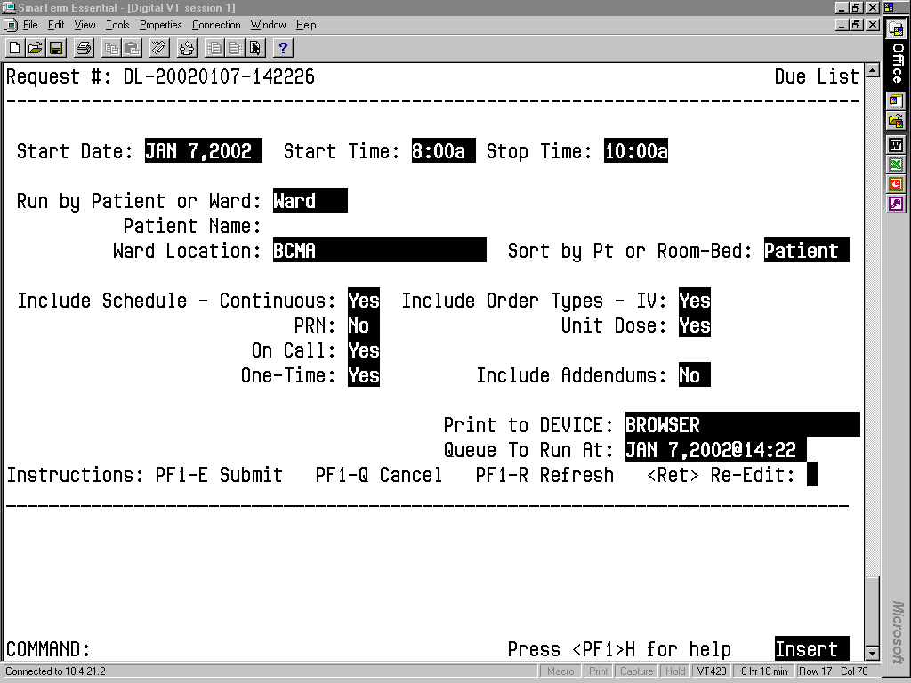
To print a Due List Report:
- At the “Select Medication Administration Menu Nursing Option:” prompt, type 5, and then press <Enter> to access the Due List [PSBO DL] option.
- At the “Start Date:” prompt, type the date, and then press <Enter>.
- At the “Start Time:” prompt, type the time, and then press <Enter>.
- At the “Stop Date:” prompt, type a date, and then press <Enter>.
- At the “Run by Patient or Ward:” prompt, type P for Patient or W for Ward, and then press <Enter>.
- If you are sorting the report by patient, at the “Patient Name:” prompt, type the patient's name or SSN, and then press <Enter>.
- If you are sorting the report by ward, in the ward location, type the ward designation, and then press <Enter>. At the “Sort by Pt or Room-Bed:” prompt, type P for Patient or R for Room/Bed, and then press <Enter>.
- At the “Include Schedule:” prompts, enter Y for Yes for the desired Schedule Type(s) and N for No for the others and, then press <Enter>.
- At the “Include Order Types:” prompts, enter Y for Yes or N for No at the “IV:” prompt and “Unit Dose:” prompt, and then press <Enter>. If you enter N for No at both prompts, no orders will print on the report.
- At the “Include Addendums:” prompt, enter Y or N, and then press <Enter>. When Y is entered, an additional section called Changes/Addendums to Orders will print at the bottom of the report. You can use this section of the report to manually record information about a medication administration.
- At the “Print to Device:” prompt, type the desired printer, and then press <Enter>.
- At the “Queue to Run At:” prompt, type the date you want to run a report, and then press <Enter>. If you press <Enter>, the system defaults to the current date and time.
- At the “<Ret> Re-Edit:” prompt, press the PF1 (or Num Lock), followed by E (Exit) to submit the request for printing. (Other available actions at this prompt are PF1 - Q to Quit, or PF1-R to refresh the screen.)

The screen clears and the following message displays:

Submitting Your Report Request to Taskman…Submitted!
Your Task Number Is: XXXX

The reports will print in a 132-column output. Exhibit 14, Due List Report by Patient, and Exhibit 15, Due List Report by Ward, show examples of both Due List Reports.

Exhibit 14: Due List Report by Patient
====================================================================================================================================
MEDICATION DUE LIST for MAR 26, 2002 0800-1000 Run Date: MAR 26, 2002@14:43
Order Type(s): IV & Unit Dose -- Continuous Page: 1

Patient: BCMAPATIENT,TWELVE SSN: 000-00-0007 DOB: DEC 3,1958 (40)
Sex: MALE Ht/Wt: */* Ward: BCMA Rm A427-03
Dx: CHEST PAIN Last Mvmt: JAN 8,2002@14:14:45 Type: SPECIALTY TRANSFER

Reactions: STRAWBERRIES
====================================================================================================================================
Self Last Start Stop Verifying
Med Sched Medication Dose Given Date Date Rph/Rn
------------------------------------------------------------------------------------------------------------------------------------
UD-C ARTIFICIAL TEARS SOLN,OPH
*ARTIFICIAL TEARS /ML (7021)
Spec Inst: WHILE AWAKE Give: 2 DROPS
0600-0800-1000-1200-1400-1600-1800-
2000-2200
Admin Times: 0800-1000 03/23/02@0824 03/12/029 04/11/02 KB/***
------------------------------------------------------------------------------------------------------------------------------------
UD-C CLOTRIMAZOLE CREAM,TOP
*CLOTRIMAZOLE 1% CREAM /GM (7071)
Spec Inst: SMALL AMOUNT TOPICALLY
TO AREA Give: QID
Admin Times: 0900 03/21/02@1601 03/12/02 04/11/02 KB/***
------------------------------------------------------------------------------------------------------------------------------------
UD-C MULTIVITAMINS TAB
*MULTIVITAMIN TAB (5512)
Spec Inst: <None Entered> Give: 20meq QOD
Admin Times: 0900 03/26/02@0842 03/12/02 04/25/02 KB/***
------------------------------------------------------------------------------------------------------------------------------------

Changes/Addendums to orders
------------------------------------------------------------------------------------------------------------------------------------

CON ___ PRN ___ Drug: ______________________ Give: __________________________________________ Start: _________ Stop: _________
Spec
OT ___ OC ___ Inst: ________________________________________________________________________ Initials: ______ Date: _________
------------------------------------------------------------------------------------------------------------------------------------

CON ___ PRN ___ Drug: ______________________ Give: __________________________________________ Start: _________ Stop: _________
Spec
OT ___ OC ___ Inst: ________________________________________________________________________ Initials: ______ Date: _________
------------------------------------------------------------------------------------------------------------------------------------
------------------------------------------------------------------------------------------------------------------------------------
====================================================================================================================================
BCMAPATIENT,TWELVE 000-00-0007 Ward: BCMA Room-Bed: A427-03

Exhibit 15: Due List Report by Ward
==========================================================================================================================
MEDICATION DUE LIST for FEB 25, 2004 0001-2400 Run Date: FEB 25, 2004@11:22
Order Type(s): IV & Unit Dose -- Continuous PRN On-Call One-Time Page: 1

Patient: BCMAPATIENT,ONE SSN: 000-00-9678 DOB: SEP 2,1947 (56)
Sex: MALE Ht/Wt: */* Ward: 7A GEN MED Rm 724-A
Dx: CHF Last Mvmt: DEC 2,2003@07:30:35 Type: ADMISSION

Reactions: STRAWBERRIES
==========================================================================================================================
Self Last Start Stop Verifying
Med Sched Medication Dose Route Given Date Date Rph/Rn
@Time @Time
--------------------------------------------------------------------------------------------------------------------------
IV-C AMPICILLIN INJ Give: Q4H IV 01/16/04@1003 12/8/03 6/21/04 ***/DD
@13:30 @12:00
*AMPICILLIN (50 GM)
*DEXTROSE 5% IN N. SALINE (1000ML)
Admin Times:
0100-0500-0900-1300-1700
-2100
Spec Inst: <None Entered>
--------------------------------------------------------------------------------------------------------------------------
IV-C DEXTROSE/SALINE INJ,SOLN Give: IV 12/8/03 6/21/04 ***/DD
@14:12 @12:00
*DEXTROSE 5% IN N. SALINE (1000 ML)
Admin Times: 0000
Spec Inst: Bolus one bag.
--------------------------------------------------------------------------------------------------------------------------
UD-C SODIUM BICARBONATE TAB Give: 325MG Q4H PO 02/13/04@1100 1/16/04 4/25/04 ***/DD
@10:00 @12:00
*SODIUM BICARBONATE 325MG TABS
(2664) Admin Times:
0100-0500-0900-1300-1700
-2100
Spec Inst: <None Entered>
--------------------------------------------------------------------------------------------------------------------------
UD-P ACETAMINOPHEN TAB Give: 650MG Q6H PRN PO 02/13/04@1059 12/8/03 6/21/04 ***/DD
@12:35 @12:00
*ACETAMINOPHEN 325MG TAB (263)
Spec Inst: <None Entered>
--------------------------------------------------------------------------------------------------------------------------
UD-P FUROSEMIDE INJ,SOLN Give: 20MG/2ML BID IVP 1/16/04 4/25/04 ***/DD
@10:28 @12:00
*FUROSEMIDE 10MG/ML 10ML INJ
(651)
Spec Inst: For congestion
--------------------------------------------------------------------------------------------------------------------------
--------------------------------------------------------------------------------------------------------------------------
==========================================================================================================================
BCMAPATIENT,ONE 000-00-9678 Ward: 7A GEN MED Room-Bed: 724-A

PRN Effectiveness List Report
The PRN Effectiveness List [PSBO PE] option lets Nursing personnel print the PRN Effectiveness List Report, which lists PRN medications administered to a patient that require an Effectiveness comment.
It also includes patient demographics data, ADR information, plus the PRN medication, administration date and time, and the individual(s) who administered the order. You can print the report by patient or by ward.

The system files the Effectiveness comment, after you make an entry using the PRN Effectiveness List [PSBO PE] option, and then select one of the medications listed on the following report. The entry will not display on the PRN Effectiveness List Report the next time that it is printed.

 You can print a PRN Effectiveness List Report after a patient has been discharged.

To print a PRN Effectiveness List Report:
- At the “Select Medication Administration Menu Nursing Option:” prompt, type 6, and then press <Enter> to access the PRN Effectiveness List [PSBO PE] option.
======================================================================================================
PRN EFFECTIVENESS LIST from Feb 02, 2002@08:00 thru Feb 02, 2002@16:00 Run Date: FEB 2,2002@13:12
Page: 1

Patient: BCMAPATIENT,NINE SSN: 000-00-1013 DOB: JAN 1,1949 (52)
Sex: FEMALE Ht/Wt: 182cm/83kg Ward: BCMA Rm 421-1
Dx: COPD Last Mvmt: NOV 27,2000@11:19:16 Type: ADMISSION

Reactions: STRAWBERRIES
======================================================================================================
Administration Date/Time Medication Administered By
------------------------------------------------------------------------------------------------------

FEB 02, 2002@09:23:05 HALOPERIDOL BCMANURSE,ONE
PRN Reason: AGITATION

FEB 02, 2002@09:23:26 ACETAMINOPHEN BCMANURSE,ONE
PRN Reason: FEVER

FEB 02, 2002@09:23:51 ALUMINUM HYDROXIDE/MAG HYDROXIDE/SIMETH BCMANURSE,ONE
PRN Reason: DYSPEPSIA

FEB 02, 2002@09:25:02 INSULIN REGULAR (HUMULIN) BCMANURSE,ONE
PRN Reason: ELEVATED BLOOD SUGAR

======================================================================================================
BCMAPATIENT,NINE 000-00-1013 Ward: BCMA Room-Bed: 421-1
2. See Section 3.2, “Using ScreenMan Format to Request a Report,” for instructions about requesting a PRN Effectiveness List Report.

The printed reports are formatted as shown in Exhibit 16, PRN Effectiveness List Report by Patient and Exhibit 17, PRN Effectiveness List Report by Ward.

Exhibit 16: PRN Effectiveness List Report by Patient

Exhibit 17: PRN Effectiveness List Report by Ward
===========================================================================================================
PRN EFFECTIVENESS LIST from Feb 04, 2004@00:01 thru Feb 04, 2004@24:00 Run Date: FEB 04, 2004@10:16
Page: 1

Ward Location: NEW LOCATION Division: ALBANY
===========================================================================================================
Patient Ward Rm-Bed
Administration Date/Time Medication Administered By
-----------------------------------------------------------------------------------------------------------

BCMAPATIENT,ONE 7A GEN MED 724-A

FEB 04, 2004@10:00:23 ACETAMINOPHEN BCMANURSE,ONE
PRN Reason: Fever

Enter PRN Effectiveness
The Enter PRN Effectiveness [PSB MED LOG PRN EFFECT] option lets Nursing personnel enter Effectiveness comments for PRN medications that were administered to a patient.

To enter PRN Effectiveness comments:
- At the “Select Medication Administration Menu Nursing Option:” prompt, type 7, and then press <Enter> to access the Enter PRN Effectiveness [PSB MED LOG PRN EFFECT] option. Additional information entry prompts will display, as illustrated in Exhibit 18, Patient Selection Screen, provided below.
- At the “Select Patient Name:” prompt, type the patient’s name or SSN, and then press <Enter>.
- At the “Select Date to Begin Searching Back From:” prompt, press <Enter> to select today’s date.
- If the medication was not administered today, a screen message will display, asking if you would like to move back one day. Press <Enter> to do so. This process will continue until the system reaches a date on which medications were administered. At that time, the list of medications will display as shown in Exhibit 19, Medication Selection Screen.

Exhibit 18: Patient Selection Screen
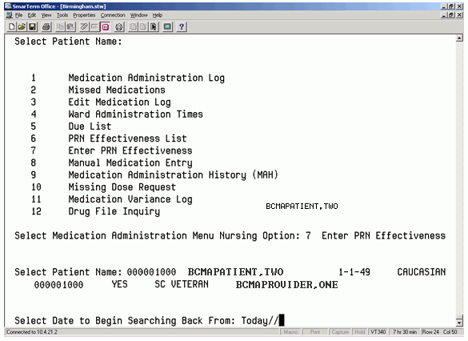

Exhibit 19: Medication Selection Screen
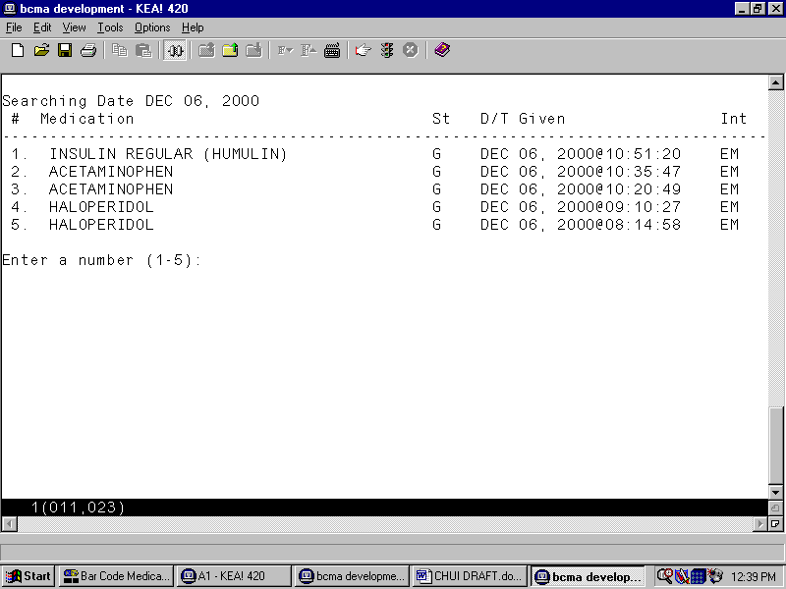

- At the “Enter a number (1-5):” prompt, type the number corresponding to the medication needing an Effectiveness comment, and then press <Enter>. The Effectiveness Comments Entry Screen displays, as shown in Exhibit 20, PRN Effectiveness Entry Screen.

Exhibit 20: PRN Effectiveness Entry Screen
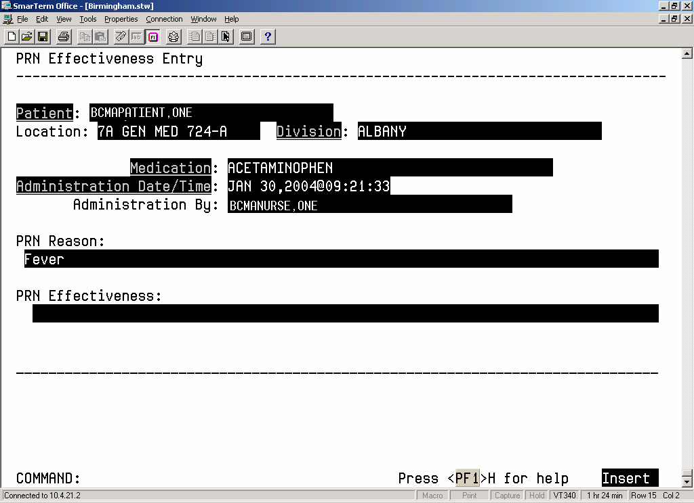

- At the “PRN Effectiveness:” prompt, type a comment (up to 150 characters), and then press <Enter>.
- At the “COMMAND:” prompt, type S for Save, E to Exit, or R for Refresh, and then press <Enter>. When you save the comments, the system adds them to the PRN Effectiveness List Report.

- If you try to exit the screen and the data has not been saved, the system will display the “Save changes before leaving form (Y/N)?” prompt. If you enter N for No, the data will not be saved. If you enter Y for Yes, the changes will be saved.

Manual Medication Entry
The Manual Medication Entry [PSB MED LOG NEW ENTRY] option lets Nursing personnel manually create a medication administration entry for any medication order. This option will also display orders that have expired or been discontinued on the date selected. Entries for expired and discontinued orders are sometimes necessary if a patient has been transferred or discharged before the administration documentation process has been completed.

- Medication orders will not be electronically validated with the Manual Medication Entry [PSB MED LOG NEW ENTRY] option. However, the Medication Log will include comments and audits for any order that was entered using the Manual Medication Entry [PSB MED LOG NEW ENTRY] option. You should limit the use of this option.

To manually create a medication administration entry for an active order:
- At the “Select Medication Administration Menu Nursing Option:” prompt, type 8, and then press <Enter> to access the Manual Medication Entry [PSB MED LOG NEW ENTRY] option. Additional information entry prompts will display, as illustrated in Exhibit 21, Manual Medication Entry Patient Selection Screen, provided below.
- At the “Select PATIENT:” prompt, type the patient’s name or SSN, and then press <Enter>.

Exhibit 21: Manual Medication Entry Patient Selection Screen
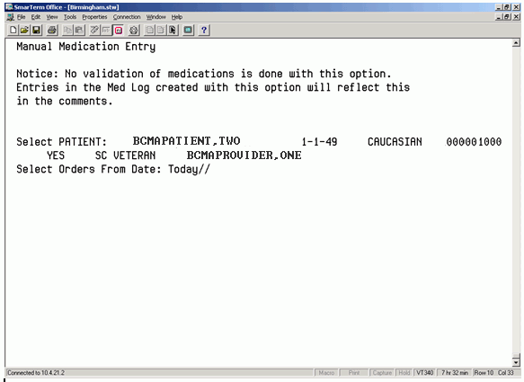
- At the “Select Orders From Date: Today//” prompt, press <Enter> to select today's date, or enter a date and then press <Enter>. A list of orders for this patient will display, as shown in Exhibit 22, Manual Medication Entry Medication Selection Screen.
- At the “Enter RETURN to continue or '^' to exit:” prompt, press <Enter> to continue with the entry.

- You can return to the Main Options Menu by entering ^, and then pressing <Enter>.

Exhibit 22: Manual Medication Entry Medication Selection Screen
Manual Medication Entry
# Sc Medication St
--------------------------------------------------------------------------------

1. C ASPIRIN TAB,EC (A) Start: 03/26/2002 0600
Stop: 04/27/2002 2400
Admin Times: 0900

2. C CEFEPIME INJ,PWDR (D) Start: 02/28/2002 1435
Stop: 03/26/2002 1037 Admin Times: 1630

3. C CEFEPIME INJ,PWDR (A) Start: 03/26/2002 1037
Stop: 04/17/2002 2400
Admin Times: 0900

4. C DILTIAZEM (TIAZAC) CAP,SA (A) Start: 03/28/2002 0700
Stop: 04/17/2002 2400
Admin Times: 0900

5. C MULTIVITAMINS TAB (A) Start: 03/26/2002 0700
Stop: 04/17/2002 2400
Admin Times: 0900

6. O LORAZEPAM TAB (E) Start: 02/28/2002 0905
Stop: 02/28/2002 0905

7. O SODIUM BIPHOSPHATE/SODIUM PHOSPHATE ENEMA (E)
Start: 03/30/2002 0905
Stop: 03/30/2002 0905

8. P HYDROCORTISONE CREAM,TOP (A) Start: 04/20/2002 0856
Stop: 05/03/2002 2400

Enter a number (1-8):

- At the “Enter a number (1-8):” prompt, type the number that corresponds to the medication in the list, and then press <Enter>. The screen illustrated in Exhibit 23, Administration Time Selection Screen, will display.

Exhibit 23: Administration Time Selection Screen
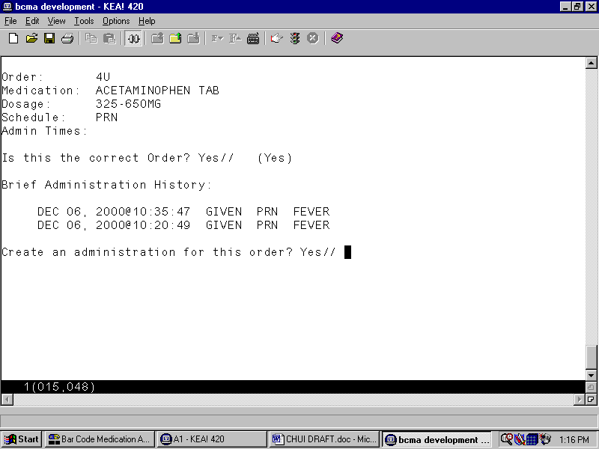

- At the “Is this the correct Order? Yes//” prompt, press <Enter> to accept the order.
- If you enter N for No, the screen reverts to the Manual Medication Entry Medication Selection Screen, shown in Exhibit 22.

- A brief Administration History for PRN medications displays up to the last four actions for the selected orderable item.

- At the “Create an administration for this order? Yes//” prompt, press <Enter> if you want to create an administration for the PRN medication. Then enter a PRN Reason (1-30 characters) at the prompt that displays, and then press <Enter>.
- At the “Select Administration Time:” prompt, type the number of the desired administration time from the list provided, and then press <Enter>. The administration date and time will display at the “Create An Administration:” prompt.
- If the date and time are correct, press <Enter>.
- If the date and time are not correct, enter N for No at the “Create An Administration:” prompt. The screen will revert to the Manual Medication Entry Medication Selection Screen, as shown in Exhibit 22. The manual entry screen displays, as shown in Exhibit 24, Medication Log Manual Entry Screen.

Exhibit 24: Medication Log Manual Entry Screen
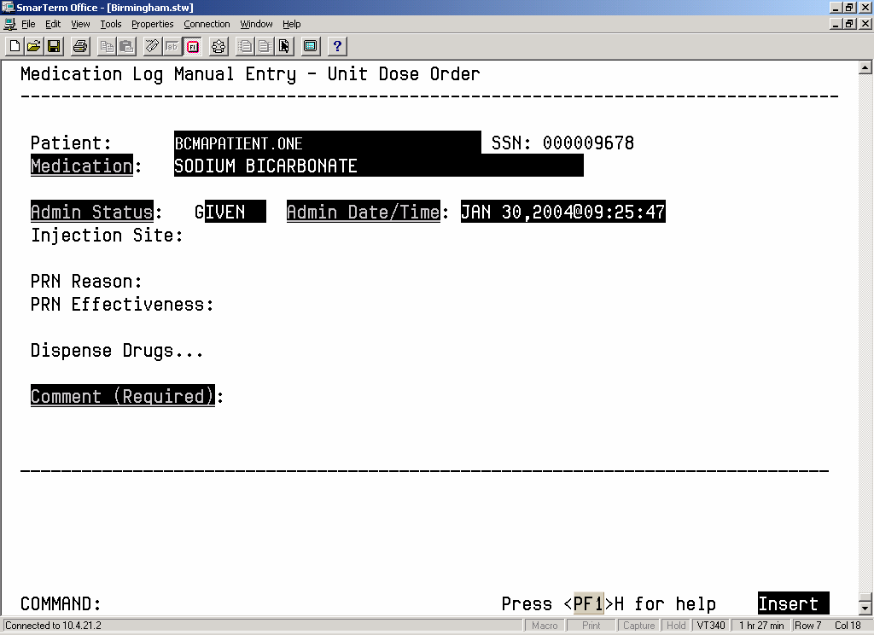

- At the “Admin Status:” prompt, type G for Given, H for Held, or R for Refused, and then press <Enter>.
- At the “Admin Date/Time:” prompt, enter the actual administration date and time, and then press <Enter>.
- At the “Injection Site:” prompt, enter a free-text comment, and then press <Enter>.
- At the “PRN Reason:” prompt, enter a free-text comment, and then press <Enter>.
- At the “PRN Effectiveness:” prompt, enter a free-text comment, and then press <Enter>.
- At the “Dispense Drugs…” prompt, press <Enter>. A Dispense Drugs Popup Box will display the Dispense Drug(s) associated with this order, the number of units ordered and actually administered, and a description of the dispensed units associated with the drug name.
- Perform the following actions:
- Change the dispense drug if desired, and then press <Enter>.
- At the “Units Given:” prompt, type a number between 0 and 50, and then press <Enter>.
- At the “Units” prompt, type the form being dispensed, such as Tablet, Capsule, or Liquid. This is a free-text entry prompt used to enter the units.
- After the Dispense Drugs information is complete, press <Enter> twice.
- At the “COMMAND: Close” prompt, press <Enter> again to close the Dispense Drugs Popup Box.
- At the “Comment (Required):” prompt, type a free-text comment (up to 150 characters), and then press <Enter>. This is a required prompt anytime an entry is creating using the Manual Medication Entry [PSB MED LOG NEW ENTRY] option. You must enter the reason the medication entry is being edited. This information displays on the Medication Administration Log when a user requests an audit.
- At the “COMMAND:” prompt, type S for Save, E for Exit, or R for Refresh, and then press <Enter>.

- If E is selected, and the data has not been saved, the system will display the “Save changes before leaving form (Y/N)?” prompt. If you enter N for No, the data will not be saved. If you enter Y for Yes, the changes will be saved.

- The screen will display the “Enter RETURN to continue or '^' to exit” prompt.
- To edit another medication administration entry, press <Enter> twice.
- To return to the Main Options Menu, enter ^, and then press <Enter>.

Medication Administration History (MAH) Report
The Medication Administration History (MAH) [PSBO MH] option lets Nursing personnel print an MAH Report for Unit Dose and IV medication orders. This report lists a clinician’s name and initials, and the exact time that an action was taken on an order (in a conventional MAR format). Each order is listed alphabetically by the orderable item. The Date column lists three asterisks (***) to indicate that a medication was not due. This information is also noted in the Legend at the bottom of the MAH Report.

An MAH Report also includes patient demographics data, allergies and ADR information, plus detailed information about the order, such as the drug/additive/solution; the medication schedule, dose, route, and injection site; the actual administration times; the name and initials of the clinician who administered the medication; and the individuals who verified the order. It also includes information about when an order is placed “On Hold” and taken “Off Hold” by a provider, and the order Start and Stop Date/Time for the medication.

- If no parameter is defined in CPRS, the maximum date range defaults to a seven-date range. For example, a report would list the Sunday proceeding, and the Saturday following, the date that you selected for the report.

- When a student nurse is administering medications under the supervision of an instructor, and both individuals hold the appropriate security keys (i.e., PSB STUDENT and PSB INSTRUCTOR), an asterisk prints next to the student’s initials on the MAH. A legend prints at the bottom of the MAH to indicate the date/time the medication was given, along with the names of the student and the instructor.

To print an MAH Report:
- At the “Select Medication Administration Menu Nursing Option:” prompt, type 9, and then press <Enter> to access the Medication Administration History (MAH) [PSBO MH] option.
- See Section 3.2, “Using ScreenMan Format to Request a Report,” for instructions about requesting an MAH. Exhibit 25, MAH Report by Patient, shows an example of the MAH Report.

Exhibit 25: Medication Administration History Report by Patient
============================================================================================================================
Continuing/PRN/Stat/One Time Medication/Treatment Record (VAF 10-2970 B, C, D) Run Date: FEB 12, 2004@13:48
Page: 1

Patient: BCMAPATIENT,ONE SSN: 000-00-9678 DOB: SEP 2, 1947 (56)
Sex: MALE Ht/Wt: */* Ward: 7A GEN MED Rm 724-A
Dx: CHF Last Mvmt: DEC 2, 2003@07:30:35 Type: ADMISSION

ADRs: No ADRs on file.

Allergies: LATEX, STRAWBERRIES
=============================================================================================================================
Start Date Stop Date | Admin | | | | | | |
and Time and Time | Times | 02/06/2004 | 02/07/2004 | 02/08/2004 | 02/09/2004 | 02/10/2004 | 02/11/2004
-----------------------------------------------------------------------------------------------------------------------------
12/08/2003 06/21/2004 | 0100 | | | | | |
@13:30 @12:00 | 0500 | | | | | |
| 0900 | | | | | |
AMPICILLIN INJ | 1300 | | | | | |
AMPICILLIN 50 GM, DEXTROSE | 1700 | | | | | |
5% IN N. SALINE 1000 ML Give: | 2100 | | | | | |
IV Q4H INFUSE OVER 20 MIN. | | | | | | |
| | | | | | |
RPH: A12 RN: | | | | | | |
-----------------------------------------------------------------------------------------------------------------------------
12/08/2003 06/21/2004 | 0000 | | | | | |
@14:12 @12:00 | | | | | | |
| | | | | | |
DEXTROSE/SALINE INJ,SOLN | | | | | | |
DEXTROSE 5% IN N. SALINE | | | | | | |
1000 ML Give: IV 100 ml/hr | | | | | | |
Spec Inst: Bolus one bag. | | | | | | |
| | | | | | |
RPH: A12 RN: | | | | | | |
-----------------------------------------------------------------------------------------------------------------------------
12/08/2003 06/21/2004 | 0100 | | | | | |
@12:50 @12:00 | 0500 | | | | | |
| 0900 | | | | | |
HALOPERIDOL TAB | 1300 | | | | | |
HALOPERIDOL 1MG S.T. Give: | 1700 | | | | | |
2MG PO Q4H | 2100 | | | | | |
ENTERED AS ACTIVE BY | | | | | | |
PHARMACIST | | | | | | |
A12 DEC 08, 2003@12:50:05 | | | | | | |
PLACED ON HOLD BY PHARMACIST | | | | | | |
A12 DEC 08, 2003@12:50:16 | | | | | | |
RPH: A12 RN: | | HOLD | HOLD | HOLD | HOLD | HOLD | HOLD
-----------------------------------------------------------------------------------------------------------------------------
01/30/2004 02/06/2004 | 0300 | | | | | |
@18:00 @24:00 | 0900 | | | | | |
| 1500 | | | | | |
METHYLDOPATE INJ | 2100 | | | | | |
METHYLDOPATE 250MG/5ML INJ | | | | | | |
Give: 50MG/1ML PO Q6H | | | | | | |
| | | | | | |
| | | | | | |
RPH: RN: DD | | | *** | *** | *** | *** | ***
-----------------------------------------------------------------------------------------------------------------------------
01/16/2004 04/25/2004 | 0100 | | | | | |
@10:00 @12:00 | 0500 | | | | | |
| 0900 | | | | | |
SODIUM BICARBONATE TAB | 1300 | | | | | |
SODIUM BICARBONATE 325MG | 1700 | | | | | |
TABS Give: 325MG PO Q4H | 2100 | | | | | |
| | | | | | |
| | | | | | |
RPH: PI RN: | | | | | | |
-----------------------------------------------------------------------------------------------------------------------------

Initial - Name Legend

Status Codes
C - Completed
G - Given
H - Held
I - Infusing
M - Missing Dose Requested
R - Refused
RM - Removed
S - Stopped
*** - Medication Not Due

Missing Dose Request

The Missing Dose Request [PSB MISING DOSE REQUEST] option lets Nursing personnel submit a Missing Dose Request to Pharmacy for filling an active medication order that is missing. This electronic request is communicated to the Pharmacy via a predefined printer and/or via an electronic MailMan message sent to a predefined mail group. Your VAMC may opt to use both mechanisms for Missing Dose Request notifications.

To submit a Missing Dose Request:
- At the “Select Medication Administration Menu Nursing Option:” prompt, type 10, and then press <Enter> to access the Missing Dose Request [PSB MISING DOSE REQUEST] option. The prompts you complete are shown in Exhibit 26, Missing Dose Request Screen.
- At the “Patient Name:” prompt, type the patient’s name or SSN, and then press <Enter>.
- At the “Missing Drug:” prompt, type the medication, and then press <Enter>.

- To view a list of appropriate formats for the “Missing Drug:” prompt, enter a ? at the “Missing Drug:” prompt, and then press <Enter>. An explanation about the ways to enter a medication will display at the bottom portion of the screen.

Exhibit 26: Missing Dose Request Screen
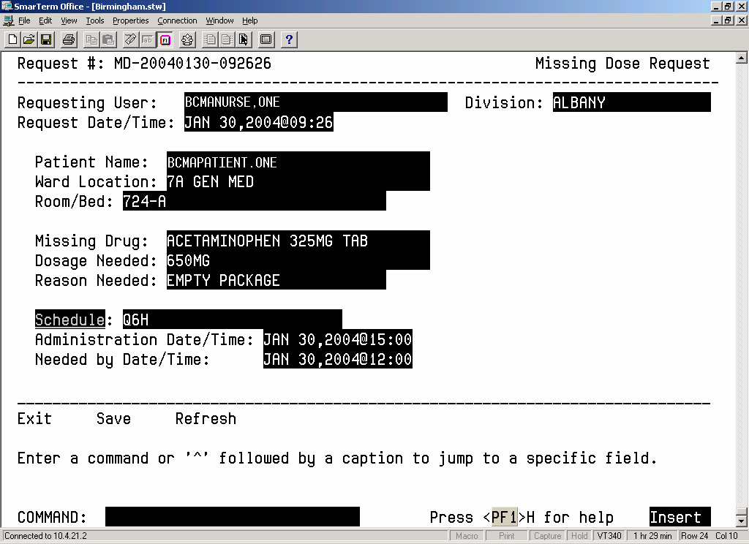
- At the “Dosage Needed:” prompt, type the dosage, and then press <Enter>.
- At the “Reason Needed:” prompt, type a reason, and then press <Enter>.

- To view a list of allowable reasons, enter a ? at the “Reason Needed:” prompt, and then press <Enter>. The list of reasons will display at the bottom portion of the screen.

- At the “Schedule:” prompt, type the schedule for the medication being requested, and then press <Enter>.
- At the “Administration Date/Time:” prompt, type a date and time (in date@time format), and then press <Enter>.
- At the “Needed by Date/Time:” prompt, type a date and time (in date@time format), and then press <Enter>.
- At the “COMMAND:” prompt, type S for Save, E for Exit, or R for Refresh, and then press <Enter>. The Missing Dose Request will print on the designated printer. The Menu Selection Screen will display with a message confirming that the request has been submitted to the Pharmacy via the appropriate mail group, as shown in Exhibit 27, Missing Dose Request Confirmation Screen.
The E-mail message that is generated displays as shown in Exhibit 28, Missing Dose E-mail Notification. The letter “M” will display in the Status column of the VDL to indicate that a Missing Dose Request was sent to the Pharmacy.

- If you try to exit the screen and the data has not been saved, the system will display the “Save changes before leaving form (Y/N)?” prompt. If you enter N for No, the data will not be saved. If you enter Y for Yes, the changes will be saved.

Exhibit 27: Missing Dose Request Confirmation Screen
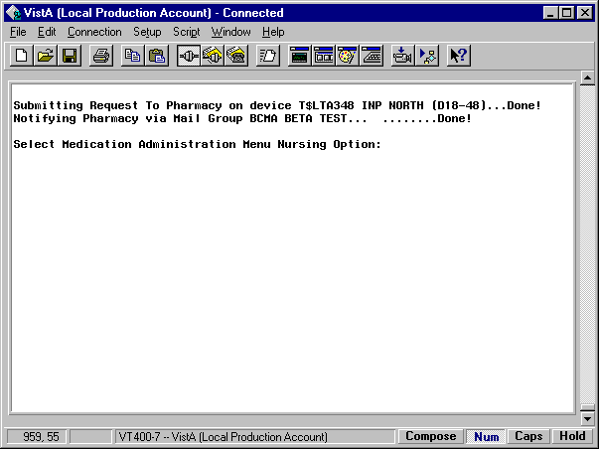

Exhibit 28: Missing Dose E-mail Notification
Subj: BCMA - Missing Dose Request [#143830] 09/24/03@09:05 17 lines
From: BCMANURSE,ONE In 'IN' basket. Page 1
---------------------------------------------------------------------

REQUEST NUMBER:.............MD-20030924-090459
DATE/TIME ENTERED:..........SEP 24, 2003@09:04
ENTERED BY:.................BCMANURSE,ONE
DIVISION:...................ALBANY, NY
SENT TO MAILGROUP:..........BCMA MISSING DOSE
PRINTED ON DEVICE:..........HOME
PATIENT:....................BCMAPATIENT,TWO
SSN (LAST 4 NUMBERS):.......1000
WARD LOCATION:..............BCMA
ROOM/BED:...................3-2
DRUG REQUESTED:.............PAPAVERINE 30MG/ML 10ML (2927)
DOSE NEEDED:................10MG
SCHEDULE:...................Q3H
REASON NEEDED:..............EMPTY PACKAGE
ADMINISTRATION DATE/TIME:...SEP 24, 2003@08:00
NEEDED BY DATE/TIME:........SEP 24, 2003@09:00

Enter message action (in IN basket): Ignore//

Medication Variance Log Report
With the Medication Variance Log [PSBO MV] option, Nursing personnel can print or display exceptions to the medication administration process. The report can be run by patient, or by ward, as shown in Exhibit 29, Medication Variance Log Report by Patient, and Exhibit 30, Medication Variance Log Report by Ward.

- This report provides users with more “event” information within a selected date range, such as the type and number of events, and the total percentage of events that occurred. A variance preceded by a minus sign (such as –24) indicates the number of minutes a medication was given before the administration time.

To print a Medication Variance Log Report:
- At the “Select Medication Administration Menu Nursing Option:” prompt, type 11, and then press <Enter> to access the Medication Variance Log [PSBO MV] option.
=================================================================================================================================

MEDICATION VARIANCE LOG Run Date: NOV 16, 2001@14:32 Page: 1

Patient: BCMAPATIENT,EIGHT SSN: 000-00-1055 DOB: FEB 2,1988 (13)
Sex: MALE Ht/Wt: 213cm/44kg Ward: 7A SURG Rm 010-A
Dx: CHF Last Mvmt: MAY 30,2001@08:02:13 Type: TRANSFER

Reactions: ACETAMINOPHEN/CHLORPHENIRAMINE/PHENYLPROPANOLAMINE, ASPIRIN/CODEINE
=================================================================================================================================
Event Date/Time Event Var Medication
---------------------------------------------------------------------------------------------------------------------------------

AUG 24, 2001@15:47:40 EARLY/LATE DOSE 227 POTASSIUM CHLORIDE
Ward: 7A SURG 010-A
Comments: <No Comments>

SEP 12, 2001@09:37:28 EARLY/LATE DOSE -443 ACETAMINOPHEN
Ward: 7A SURG 010-A
Comments: <No Comments>

SEP 12, 2001@12:14:20 EARLY/LATE DOSE 434 ACETAMINOPHEN
Ward: 7A SURG 010-A
Comments: <No Comments>

OCT 05, 2001@15:20:55 EARLY/LATE DOSE -340 BIPERIDEN
Ward: 7A SURG 010-A
Comments: <No Comments>

OCT 09, 2001@13:02:19 EARLY/LATE DOSE 242 BIPERIDEN
Ward: 7A SURG 010-A
Comments: 10/09/01 15:06 By: VN Entry created with 'Manual Medication Entry' option.
10/09/01 15:06 By: VN CHECKING GIVEN

OCT 09, 2001@14:08:12 EARLY/LATE DOSE 308 BIPERIDEN
Ward: 7A SURG 010-A
Comments: 10/09/01 15:06 By: VN Entry created with 'Manual Medication Entry' option.
10/09/01 15:06 By: VN CHECKING GIVEN

OCT 09, 2001@14:19:47 EARLY/LATE DOSE 319 BIPERIDEN
Ward: 7A SURG 010-A
Comments: 10/09/01 15:06 By: VN Entry created with 'Manual Medication Entry' option.
10/09/01 15:06 By: VN CHECKING GIVEN

OCT 11, 2001@09:26:41 LATE PRN EFFECT 15 SALICYLIC ACID
Ward: 7A SURG 010-A
Comments: <No Comments>

Total Number of Events for the reporting period is: 9

Total number of EARLY/LATE DOSE events is 8.
Percentage of Total Events: 89%

Total number of LATE PRN EFFECT events is 1.
Percentage of Total Events: 11%

==================================================================================================================================
BCMAPATIENT,EIGHT 000-00-1055 Ward: 7A SURG Room-Bed: 010-A
- See Section 3.2, “Using ScreenMan Format to Request a Report,” for instructions about requesting a Medication Variance Log.

Exhibit 29: Medication Variance Log Report by Patient

Exhibit 30: Medication Variance Log Report by Ward
====================================================================================================================================

MEDICATION VARIANCE LOG Run Date: NOV 16, 2001@14:34

Page: 2

Ward Location: 7A SURG Division: ALBANY

====================================================================================================================================

Ward Patient Name Event Date/Time Event Var Medication

------------------------------------------------------------------------------------------------------------------------------------

7A SURG 010-A BCMAPATIENT,ONE AUG 24, 2001@15:47:40 EARLY/LATE DOSE 227 POTASSIUM CHLORIDE

Ward: 7A SURG 010-A

Comments: <No Comments>

SEP 12, 2001@09:37:28 EARLY/LATE DOSE -443 ACETAMINOPHEN

Ward: 7A SURG 010-A

Comments: 09/12/01 09:37 By: RR

SEP 12, 2001@12:14:20 EARLY/LATE DOSE 434 ACETAMINOPHEN

Ward: 7A SURG 010-A

Comments: <No Comments>

OCT 05, 2001@15:20:55 EARLY/LATE DOSE -340 BIPERIDEN

Ward: 7A SURG 010-A

Comments: <No Comments>

OCT 09, 2001@13:02:19 EARLY/LATE DOSE 242 BIPERIDEN

Ward: 7A SURG 010-A

Comments: 10/09/01 15:06 By: VN Entry created with 'Manual Medication Entry' option.

10/09/01 15:06 By: VN CHECKING GIVEN

OCT 09, 2001@14:08:12 EARLY/LATE DOSE 308 BIPERIDEN

Ward: 7A SURG 010-A

Comments: 10/09/01 15:06 By: VN Entry created with 'Manual Medication Entry' option.

10/09/01 15:06 By: VN CHECKING GIVEN

OCT 09, 2001@14:19:47 EARLY/LATE DOSE 319 BIPERIDEN
Ward: 7A SURG 010-A
Comments: 10/09/01 15:06 By: VN Entry created with 'Manual Medication Entry' option.
10/09/01 15:06 By: VN CHECKING GIVEN

OCT 09, 2001@14:29:32 EARLY/LATE DOSE 329 BIPERIDEN
Ward: 7A SURG 010-A
Comments: 10/09/01 15:06 By: VN Entry created with 'Manual Medication Entry' option.
10/09/01 15:06 By: VN CHECKING GIVEN

OCT 11, 2001@09:26:41 LATE PRN EFFECT 15 SALICYLIC ACID
Ward: 7A SURG 010-A
Comments: <No Comments>

Total Number of Events for the reporting period is: 9

Total number of EARLY/LATE DOSE events is 8.
Percentage of Total Events: 89%

Total number of LATE PRN EFFECT events is 1.
Percentage of Total Events: 11%

Drug File Inquiry
The Drug File Inquiry [PSB DRUG INQUIRY] option lets Nursing and Pharmacy personnel check the bar-coded Internal Entry Number (IEN) Code listed on dispensed Unit Dose medications. This is particularly useful in helping resolve discrepancies when the incorrect bar code is affixed to a medication.

On a medication bar code, the IEN appears on the first line next to the Drug name. Any additional synonyms loaded into Pharmacy Data Management V. 1.0 also appear under the Synonym heading of this option.

To run a drug file inquiry:
- At the “Select Medication Administration Menu Nursing Option:” prompt, type 12, and then press <Enter> to access the Drug File Inquiry [PSB DRUG INQUIRY] option.
- At the “Select DRUG:” prompt, as shown in Exhibit 31, Drug File Inquiry Screen 1, type the name and dosage of the drug, and then press <Enter>.

- You can display a list by entering a ? at the “Select DRUG:” prompt, and then pressing <Enter>. The Drug File information will display, as illustrated in Exhibit 32, Drug File Inquiry Screen 2.

Exhibit 31: Drug File Inquiry Screen 1
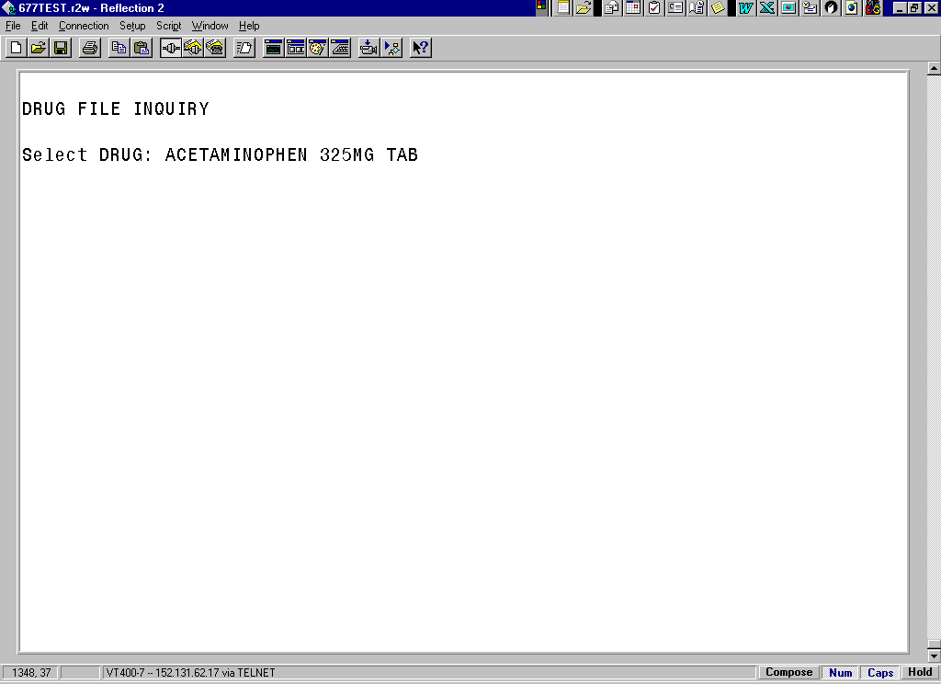

Exhibit 32: Drug File Inquiry Screen 2
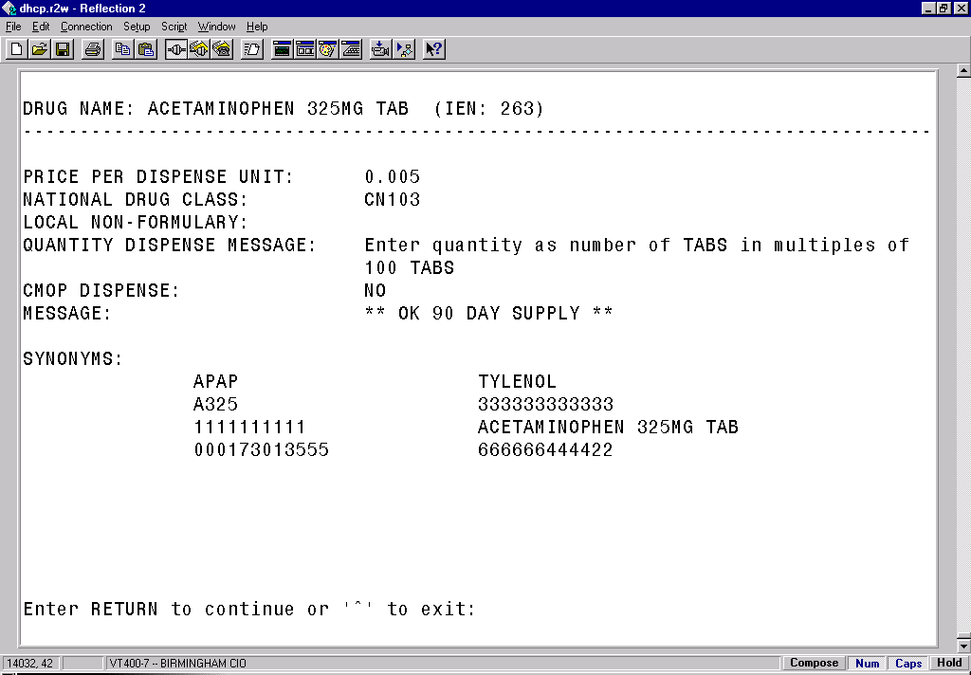

- The IEN displays on the first line, to the right of the Drug Name. The IEN is unique to this drug file entry. In most cases, it is the bar-coded number on the Unit Dose packages that are created in the Pharmacy. Manufacturers’ National Drug Code (NDC) bar codes may display at the “SYNONYMS:” prompt of this display. If the drug is Non-Formulary (N/F), the “Non-Formulary:” prompt will be set to N/F.

glossary
This section contains definitions for acronyms and terms used throughout this manual.

Acronyms

ADR | Adverse Drug Reaction.
BCMA | Bar Code Medication Administration.
CHUI | Character-based User Interface.
CPRS | Computerized Patient Record System.
GUI | Graphical User Interface.
IEN | Internal Entry Number.
IV | Intravenous.
MAH | Medication Administration History.
MAR | Medication Administration Record.
N/F | Non-formulary
NDC | National Drug Code.
PRN | Pro Re Nata, or “as needed.”
VDL | Virtual Due List.
VISTA | Veterans Health Information Systems and Technology Architecture.

Terms

ADR | Adverse Drug Reaction. Any response to a drug which is noxious and unintended, and which occurs at doses normally used in humans for treatment, diagnosis, or therapy of a disease, or for modifying physiological functions, including toxicity caused by overdose, drug interaction, drug abuse, drug withdrawal, significant failure of expected action, food-drug interaction, or allergy.
Administration History Report | A report in CPRS that lists the date, time, and orderable item of a medication highlighted on the CPRS Meds Tab. This report is called “Medication History Report” in BCMA.
Audits | The process that tracks the activities of nurses administering medications, by recording selected types of events in the patient’s Medication Log.
BCMA | A VISTA software application used in VAMCs for validating patient information and medications against active medication orders before being administered to a patient.
Clinician | VAMC personnel who administer active medication orders to patients on a ward. In a VAMC, a number of teams may be assigned to take care of one ward, with specific rooms and beds assigned to each team.
Completed | This status for an IV bag indicates that the infusion has been completed, and the bag is being taken down or replaced with a new bag. No additional actions may be taken on a bag marked as “Completed,” other than to enter comments.
Continuous Order | A medication given continuously to a patient for the life of the order, as defined by the order Start and Stop Date/Time.
CPRS | A VISTA software application that allows users to enter patient orders into different software packages from a single application. All pending orders that appear in the Unit Dose and IV packages are initially entered through the CPRS package. Clinicians, managers, quality assurance staff, and researchers use this integrated record system.
Dispensed Drug | A drug whose name has the strength associated with it (e.g., Acetaminophen 325 mg). The name without the strength is called the “Orderable Item Name.”
Due List Report | A report that provides detailed information about active and future Unit Dose and IV medication orders that are “due” for administering to a patient during a time frame that you specify within a 24-hour period.
Given | When a medication is administered to a patient, it is considered to be “Given” and marked as such (with a “G”) in the Status column of the VDL.
GUI | Graphical User Interface. The type of interface chosen for BCMA.
Held | When a medication is not actually taken by a patient, it is considered to be “Held” and marked as such (with an “H”) in the Status column of the VDL. Reasons might include the patient being temporarily off the ward. You can select and mark multiple medications as Held on the VDL using the Right Click drop-down menu. In the case of IV bags, this status indicates that the dose was Held. The only actions available for this type of IV bag are to mark the bag as Infusing or Refused, or to submit a Missing Dose Request to the Pharmacy.
Hold | To display a medication order grayed out on the VDL until its Stop Date/Time or until it is Given. Some medical centers require that a nurse mark these order types as “Held,” although it is not necessary that they do so.
IEN Code | The internal entry drug number entered by Pharmacy personnel into the DRUG file (#50) to identify Unit Dose and IV medications.
Infusing | This status, for an IV bag, indicates that the bag is actively being infused. A nurse can enter a comment by right clicking on the bag. If an IV bag is scanned, the only allowable actions are to mark the IV bag as Stopped or Completed.
IV | A medication given intravenously (within a vein) to a patient from an  IV Bag. IV types include Admixture, Chemotherapy, Hyperal, Piggyback, and Syringe.
MAH | A patient report that lists a clinician’s name and initials, and the exact time that an action was taken on an order (in a conventional MAR format). Each order is listed alphabetically by the orderable item. The Date column lists three asterisks (***) to indicate that a medication is not due. The report also lists information about when an order is placed “On Hold” and taken “Off Hold” by a provider, and the order Start and Stop Date/Time for the medication.
Medication Administration History Report | Also called “MAH,” A patient report that lists a clinician’s name and initials, and the exact time that an action was taken on an order (in a conventional MAR format). Each order is listed alphabetically by the orderable item. The Date column lists three asterisks (***) to indicate that a medication is not due. The report also lists information about when an order is placed “On Hold” and taken “Off Hold” by a provider, and the order Start and Stop Date/Time for the medication.
Medication History Report | A report in BCMA that lists the date, time, and orderable item of a medication selected on the VDL. This report is called “Administration History Report” in CPRS.
Medication Log Report | Also called “Med Log,” a report that lists every action taken on a medication order within a specified 24-hour period. You can choose to include Comments and Audits performed on the patient’s medication orders.

Missing Dose | A medication considered “Missing.” BCMA automatically marks this order type (with an “M”) in the Status column of the VDL after you submit a Missing Dose Request to the Pharmacy. If an IV bag displayed in the IV Bag Chronology display area of the VDL is not available for administration, you may mark the IV bag as a “Missing Dose” using the Missing Dose button or by right clicking the IV bag and selecting the Missing Dose command in the Right Click drop-down menu.
Missed Medications Report | A report that lists information about Continuous and One-Time Unit Dose and IV Piggyback medications that were not administered to a patient.
National Drug Code | Also called “NDC,” the number assigned by a manufacturer to each item/medication administered to a patient.
Not Given | The status that a scanned medication marked as “Given,” but not actually taken by a patient, is changed to on the VDL – by using the “Undo-Given” option. The administration will display on the VDL as it appeared before it was marked as “Given.” BCMA notes the status change only in the Audit Trail section of the Medication Log (not on the VDL).
NOW Order | A medication order given ASAP to a patient, entered as a One-Time order by Providers and Pharmacists. This order type displays for a fixed length of time on the VDL, as defined by the order Start and Stop Date/Time.
On-Call Order | A specific order or action dependent upon another order or action taking place before it is carried out. For example, “Cefazolin 1gm IVPB On Call to Operating Room.” Since it may be unknown when the patient will be taken to the operating room, the administration of the On-Call Cefazolin is dependent upon that event.
One-Time Order | A medication order given one time to a patient such as a STAT or NOW order. This order type displays for a fixed length of time on the VDL, as defined by the order Start and Stop Date/Time or until it is Given.
Orderable Item | A drug whose name does NOT have the strength associated with it (e.g., Acetaminophen 325 mg). The name with a strength is called the “Dispensed Drug Name.”
PRN Effectiveness List Report | A report that lists PRN medications administered to a patient that needs Effectiveness comments.
Provider | Another name for the “Physician” involved in the presecription of a medication (i.e., Unit Dose or IV) to a pateint.
PSB CPRS MED BUTTON | The name of the security “key” that must be assigned to nurses who document verbal- and phone-type STAT and medication orders using the CPRS Med Order Button on the BCMA VDL.

PSB INSTRUCTOR | The name of the security “key” that must be assigned to nursing instructors, supervising nursing students, so they can access user options within BCMA V. 3.0.
PSB MANAGER | The name of the security “key” that must be assigned to managers so they can access the PSB Manager options within BCMA V. 3.0.
PSB STUDENT | The name of the security “key” that must be assigned to nursing students, supervised by nursing instructors, so they can access user options with BCMA V. 3.0. This key requires that a nursing instructor sign on to BCMA V. 3.0.
Refused | The status for an IV bag or Unit Dose to indicate that the patient refused to take the dose.
Removed | The status for a patch (i.e., Nitroglycerin, Fentanyl, or Nicotine) to indicate that it has been removed from a patient. Once removed, the letters “RM” (for “Removed”) display in the Status column of the VDL.
Schedule | The frequency at which a medication is administered to a patient. For example, QID, QD, QAM, Q4H.
Schedule Type | Identifies the type of schedule (i.e., Continuous, PRN, On-Call, and One-Time) for the medication being administered to a patient.
Security Keys | Used to access specific options within BCMA that are otherwise “locked” without the security key. Only users designated as “Holders” may access these options.
Start Date/Time | The date and time that a medication is scheduled for administration to a patient.
STAT Order | A medication order given immediately to a patient, entered as a One-Time order by providers and pharmacists. This order type displays for a fixed length of time on the VDL, as defined by the order Start and Stop Date/Time.
Status | A code used to inform a clinician about the condition or progress of a medication order. For Unit Dose and IVP/IVPB orders, status codes include G=Given, H=Held, R=Refused, M=Missing, and RM=Removed (patch removal only). For IV orders, status codes include I=Infusing, H=Held, R=Refused, S=Stopped, C=Completed, and M=Missing.
Stop Date/Time | The date and time that a medication order will expire, and should no longer be administered to a patient.
Stopped | This status, for an IV bag, indicates that the IV bag was scanned as Infusing, but was then stopped by a nurse. An IV bag may be stopped and restarted for a variety of reasons. The only actions allowed on a “Stopped” IV bag is to mark the bag as Infusing, Completed, Held, or Refused.
Unit Dose | A medication given to a patient, such as tablets or capsules.
VDL | An on-line “list” used by clinicians when administering active medication orders (i.e., Unit Dose, IV Push, IV Piggyback, and large-volume IVs) to a patient. This is the Main Screen in BCMA.

Verify | When a nurse or a pharmacist confirms that a medication order is accurate and complete, according to the information supplied by the provider.
Virtual Due List | Also called “VDL,” an on-line list used by clinicians when administering active medication orders to a patient. This is the Main Screen in BCMA.

INDEX

Acronyms, 47
BCMA
Defined, 1
Documentation Conventions, 3
Features, 1
Intranet Documentation, 3
On-line Help, 3
Menu Pharmacy Options, 5
Package Conventions, 3
Glossary, 47-52
Sample Reports
Administration Times Report by Patient, 20
Administration Times Report by Ward, 21
Due List Report by Patient, 24
Due List Report by Ward, 25
Medication Administration History Report by Patient, 37
Medication Administration Log Report by Patient, 9
Medication Administration Log Report by Ward, 10
Medication Variance Log Report by Patient, 42
Medication Variance Log Report by Ward, 43
Missed Medications Report by Patient, 12
Missed Medications Report by Ward, 13
PRN Effectiveness List Report by Patient, 26
PRN Effectiveness List Report by Ward, 27
Sample Screens
Administration Time Selection Screen, 33
BCMA Nursing Option Menu Screen, 5
Drug File Inquiry Screen, 44-45
Due List Report Request Screen, 22
Manual Medication Entry Medication Selection Screen, 32
Manual Medication Entry Patient Selection Screen, 31
Medication Log Manual Entry Screen, 34
Medication Selection Screen, 29
Missing Dose E-mail Notification, 41
Missing Dose Request Confirmation Screen, 40
Missing Dose Request Screen, 38
Patient Selection Screen, 28
PRN Effectiveness Entry Screen, 30
Special Notations, 3

Using the Medication Administration Menu Nursing Options
Drug File Inquiry, 44-45
Due List Report, 22-25
Enter PRN Effectiveness, 28-30
Manual Medication Entry, 31-35
Medication Administration History (MAH) Report, 36-37
Medication Administration Log Report, 8-10
Medication Variance Log Report, 42-43
Missed Medications Report, 11-13
Missing Dose Request, 38-41
PRN Effectiveness List Report, 26-30
Ward Administration Times Report, 19-21
Using ScreenMan Format to Request a Report, 6-7

